|  |  |  |
| --- | --- | --- |
| **INDEX** | | |
| **S.No** | **TOPIC** | **Page No.** |
| 1 | SYNOPSIS |  |
| 2 | CODE |  |
| 3 | PYTHON SCREENSHOTS |  |
| 4 | SQL SCREENSHOTS |  |
| 4 | TEXT FILE SCREENSHOTS |  |
| 5 | FUTURE IMPROVEMENTS |  |
| 6 | BIBILOGRAPHY/RESOURCES |  |

**PROJECT SYNOPSIS**

**Title of the project:**

Thunderbolt web browser

**Team members:**

Armaan Patnaik

CR Sairam

**Team details:**

Our project “Thunderbolt Browser ” has been designed and developed solely by the two mentioned individuals. The various components of the project were jointly developed that is the coding and overall framework has been done by Armaan and Sairam.

**Reasons for choosing the topic:**

Internet has become a very important part of our lives nowadays. The medium of accessing the internet is through Web browser. However, as we use these browsers in a day to day basis we come across these frustrating problems of slow loading time, unexpected crashing and strange pop-ups. These big browsers also take advantage of their huge user base by compromising on security, using cookies, monitoring your search patterns to recommend you products and services. Not only does this slow down your browser but also takes a toll on users’ privacy. This is why we decided to develop a web browser that’s simple, easy to use, secured and gives you fast loading web pages that just saves the users time without being wasted by cookies and other web monitoring tools. Thunderbolt browser has been developed on PyCharm.

**Objective:**

* Providing users an Intuitive and faster browsing experience.
* Providing a Secured network of browsing
* Providing an user friendly interface with options like Bookmarks, History, signing into accounts.

**Hardware required:**

* A Desktop/Laptop
* Operating system windows 7 and above/Mac/Linux
* 4 GB of RAM
* 5 GB of free disk space

**Software requirements:**

* Python 3.6 and above
* PyCharm preinstalled
* MySQL application pre-installed.
* Tkinter
* Modules such as os, Mysql connector imported
* PyQt5 package installed in PyCharm.

**Limitations:**

* Thunderbolt Might not be as modern and flashy browser like most browsers today.
* No Customizable options available it’s predefined and a fixed layout.
* Number of tabs that can be opened are limited.
* No option to use trackpads in laptops to slide to go back or forward like in some browsers.

**References:**

* PyQt5 tutorial
* Geeksforgeeks.com
* Btechgeeks.com
* Tutorialspoint.com

**CODE:**

import PyQt5  
import sys  
import os  
from PyQt5.QtCore import *  
from PyQt5.QtWidgets import *  
from PyQt5.QtWebEngineWidgets import *  
from PyQt5.QtGui import *  
from PyQt5 import QtGui  
from PyQt5 import QtCore  
from PyQt5 import QtWidgets  
from PyQt5.QtWidgets import (QApplication, QMainWindow, QPushButton,  
 QToolTip, QMessageBox, QLabel)  
import mysql.connector

class Mainwindow(QMainWindow):  
 def __init__(self):  
 super(Mainwindow, self).__init__()  
 self.browser = QWebEngineView()  
 self.browser.setUrl(QUrl('http://google.com'))  
 self.setWindowTitle("THUNDERBOLT BROWSER")  
 self.setCentralWidget(self.browser)  
 self.showMaximized()  
 navbar = QToolBar()  
 navbar.setFixedHeight(36)  
 self.addToolBar(navbar)

self.setWindowIcon(QtGui.QIcon(QPixmap('Thunderbolt-removebg-preview.png')))  
 self.initUI()  
  
  
 back_btn = QAction(QIcon('back4.png'),'back',self)  
 back_btn.triggered.connect(self.browser.back)  
 navbar.addAction(back_btn)  
  
 fwd_btn=QAction(QIcon('forward5.png'), 'Forward',self)  
 fwd_btn.triggered.connect(self.browser.forward)  
 navbar.addAction(fwd_btn)  
  
 reload=QAction(QIcon('Reload.png'),'reload',self)  
 reload.triggered.connect(self.browser.reload)  
 navbar.addAction(reload)  
  
  
 def navigate_to_home(self):  
 self.browser.setUrl(QUrl('http://google.com'))

home=QAction(QIcon('Home.png'), 'Home',self)  
 home.triggered.connect(lambda:navigate_to_home(self))  
 navbar.addAction(home)

def navigate_to_url(self):  
 url = self.url_bar.text()  
 url='http://www.'+url  
 self.browser.setUrl(QUrl(url))

self.url_bar = QLineEdit()  
 self.url_bar.setFixedWidth(1000)  
 self.url_bar.setFixedHeight(30)  
 self.url_bar.returnPressed.connect(lambda:navigate_to_url(self))  
 navbar.addWidget(self.url_bar)  
  
  
 def initUI(self):  
  
 cs = self.menuBar()  
 a=cs.addMenu('file')  
 a.addAction("edit")  
 a.addAction("view")

b=cs.addMenu("history")  
 b.addAction("http://www.youtube.com")  
 b.addAction("http://www.yahoo.com")  
 b.addAction("http://www.stackoverflow.com")

c=cs.addMenu('help')  
 c.addAction("help link")  
 c.addAction("documents")

d=cs.addMenu("bookmarks")  
 d.addAction("http://www.teams.com")  
 d.addAction("http://www.amazon.com")  
 d.addAction("http://www.flipkart.com")

cs.setNativeMenuBar(False)  
  
 centralWidget = QWidget()  
 lay = QVBoxLayout(centralWidget)

import tkinter as tk  
import mysql.connector  
from tkinter import *  
  
  
def submitact():  
 user = Username.get()  
 passw = password.get()  
  
 print(f"The name entered by you is {user} {passw}")  
  
  
 logintodb(user, passw)

f = open(r'C:\Users\Sairam\Desktop\proj.txt', 'w')  
def logintodb(user, passw):  
  
 if passw:  
 db = mysql.connector.connect(host="localhost",  
 user="root",  
 password="rrsm7617",  
 db="email")  
 cursor = db.cursor()  
  
  
 else:  
 db = mysql.connector.connect(host="localhost",  
 user="root", password="rrsm7617",  
 db="email")  
 cursor = db.cursor()  
  
 savequery = "select * from custdetails"  
  
  
 cursor.execute(savequery)  
 myresult = cursor.fetchall()

for x in myresult:  
 f.write(str(x)+'\n')  
 print(x)  
  
 print("CONNECTED TO THE SQL DATABASE")  
  
  
 db.rollback()

root = tk.Tk()  
root.geometry("300x300")  
root.title("LOGIN ")  
  
# Defining the first row  
lblfrstrow = tk.Label(root, text="Userid -", )  
lblfrstrow.place(x=50, y=20)

Username = tk.Entry(root, width=35)  
Username.place(x=150, y=20, width=100)

lblsecrow = tk.Label(root, text="Password -")  
lblsecrow.place(x=50, y=50)

password = tk.Entry(root, width=35)  
password.place(x=150, y=50, width=100)

submitbtn = tk.Button(root, text="Login",  
 bg='blue', command=submitact)

submitbtn.place(x=150, y=135, width=55)  
  
root.mainloop()  
f.close()  
  
  
  
app=QApplication(sys.argv)  
#QApplication.setApplicationName('Arrow')  
path = os.path.join(os.path.dirname(sys.modules[__name__].__file__),

'Thunderbolt-removebg-preview.png')  
app.setWindowIcon(QIcon(path))  
window=Mainwindow()  
window.show()

#app.exec()  
sys.exit(app.exec_())

**PYTHON SCREENSHOTS:**

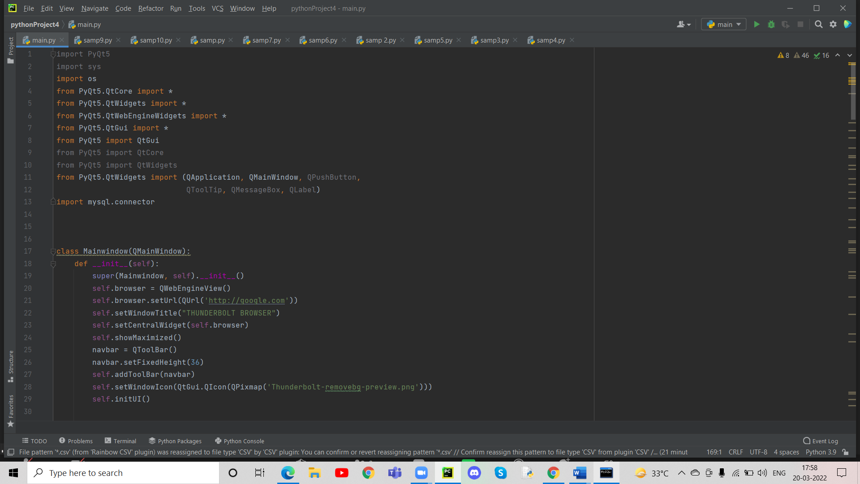

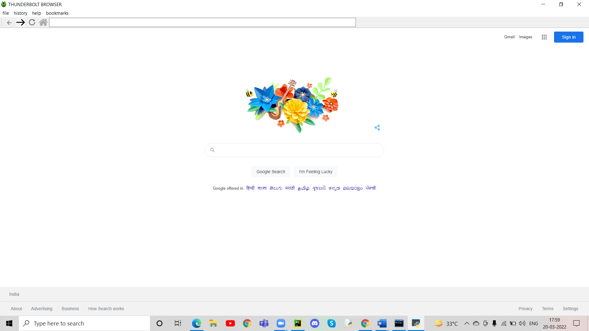

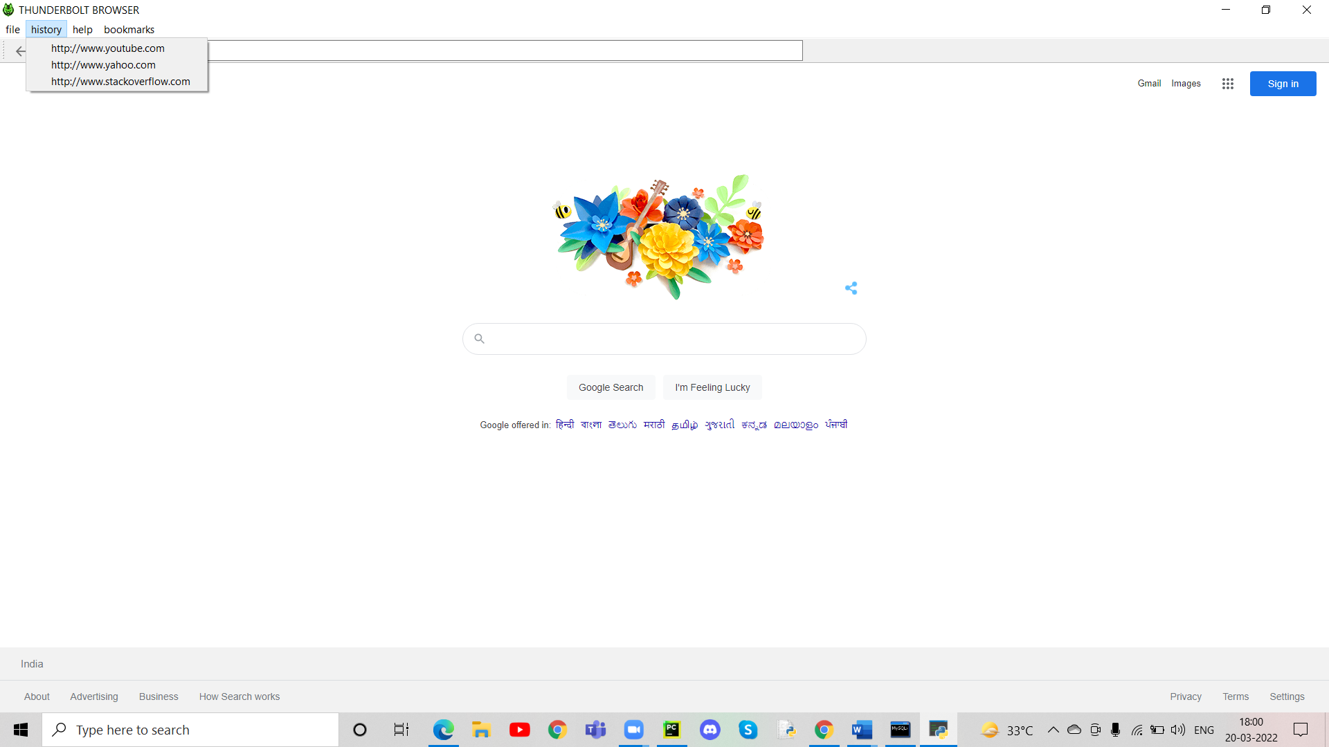

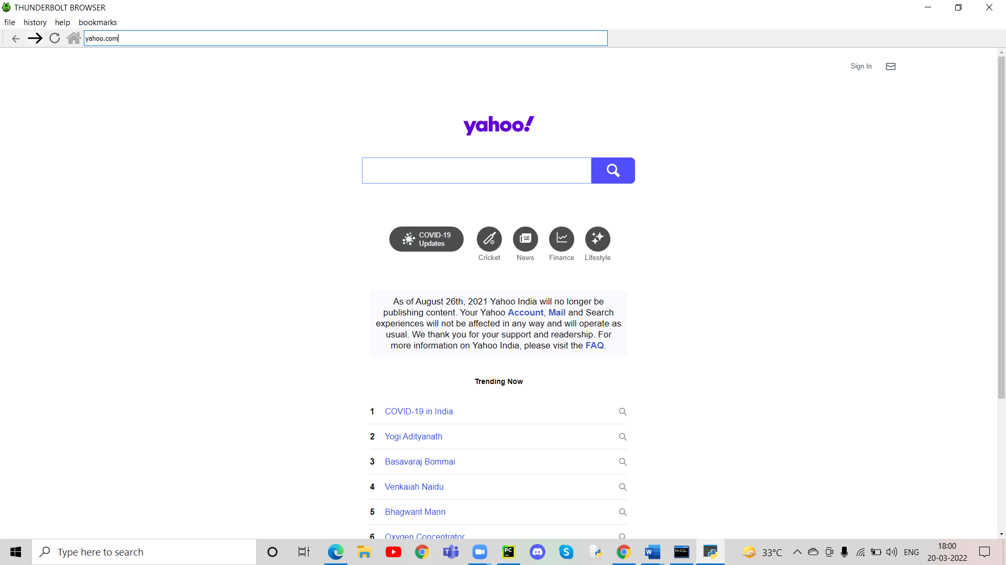

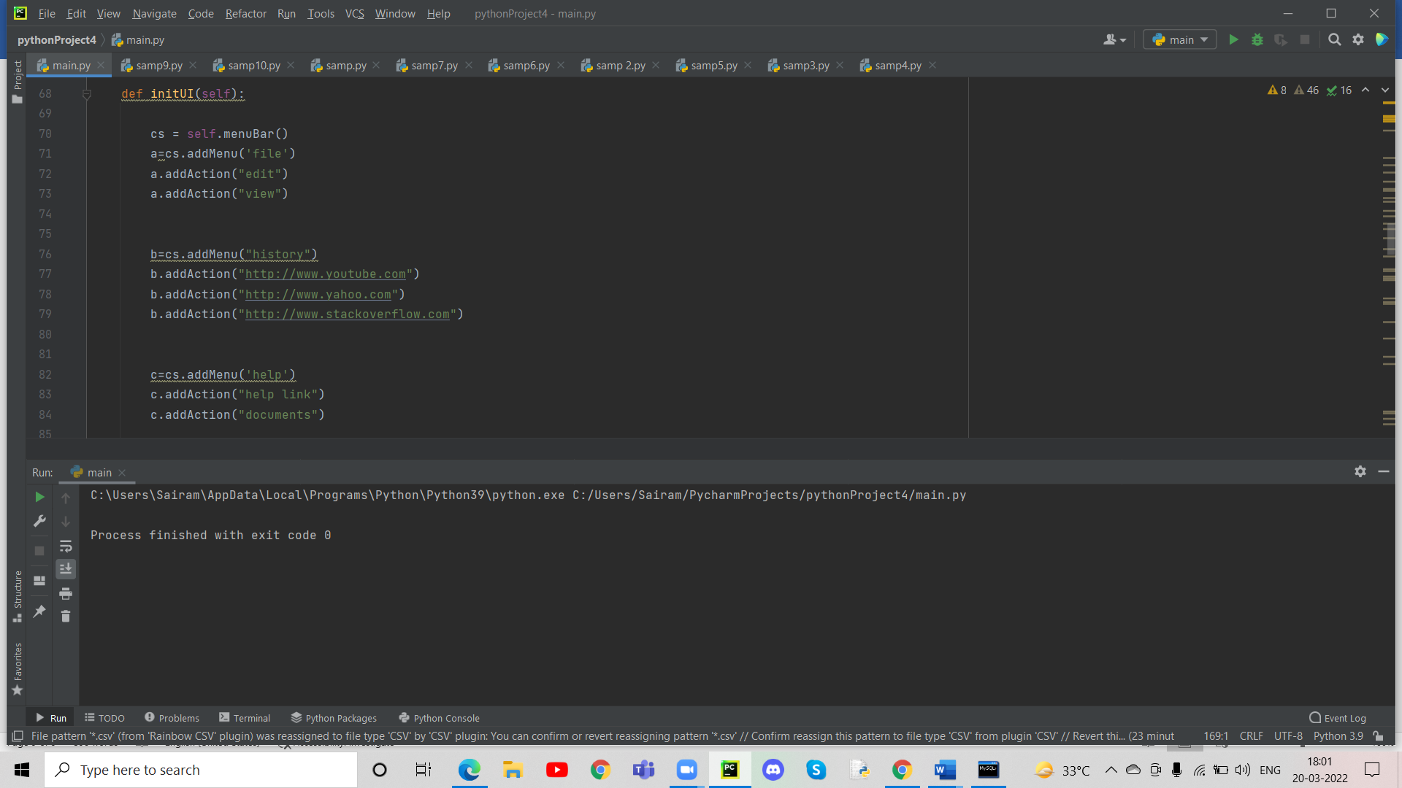

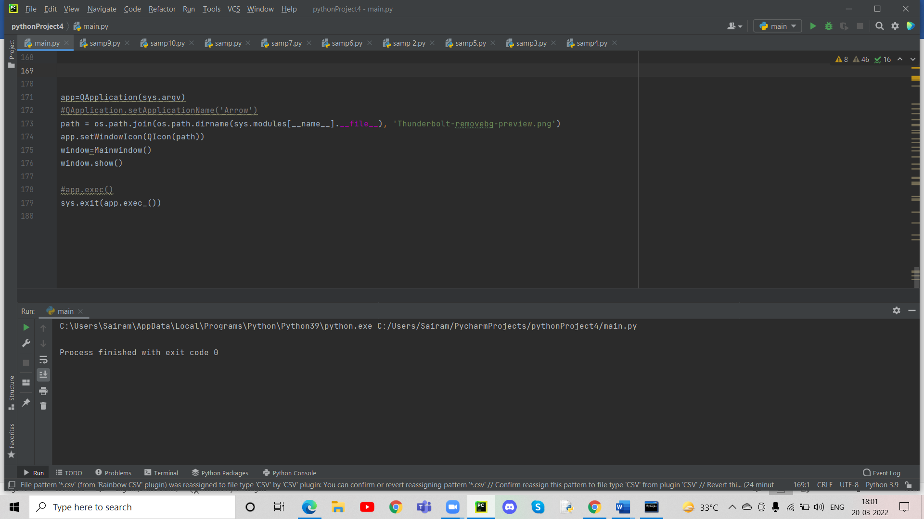

**MYSQL SCREENSHOTS:**

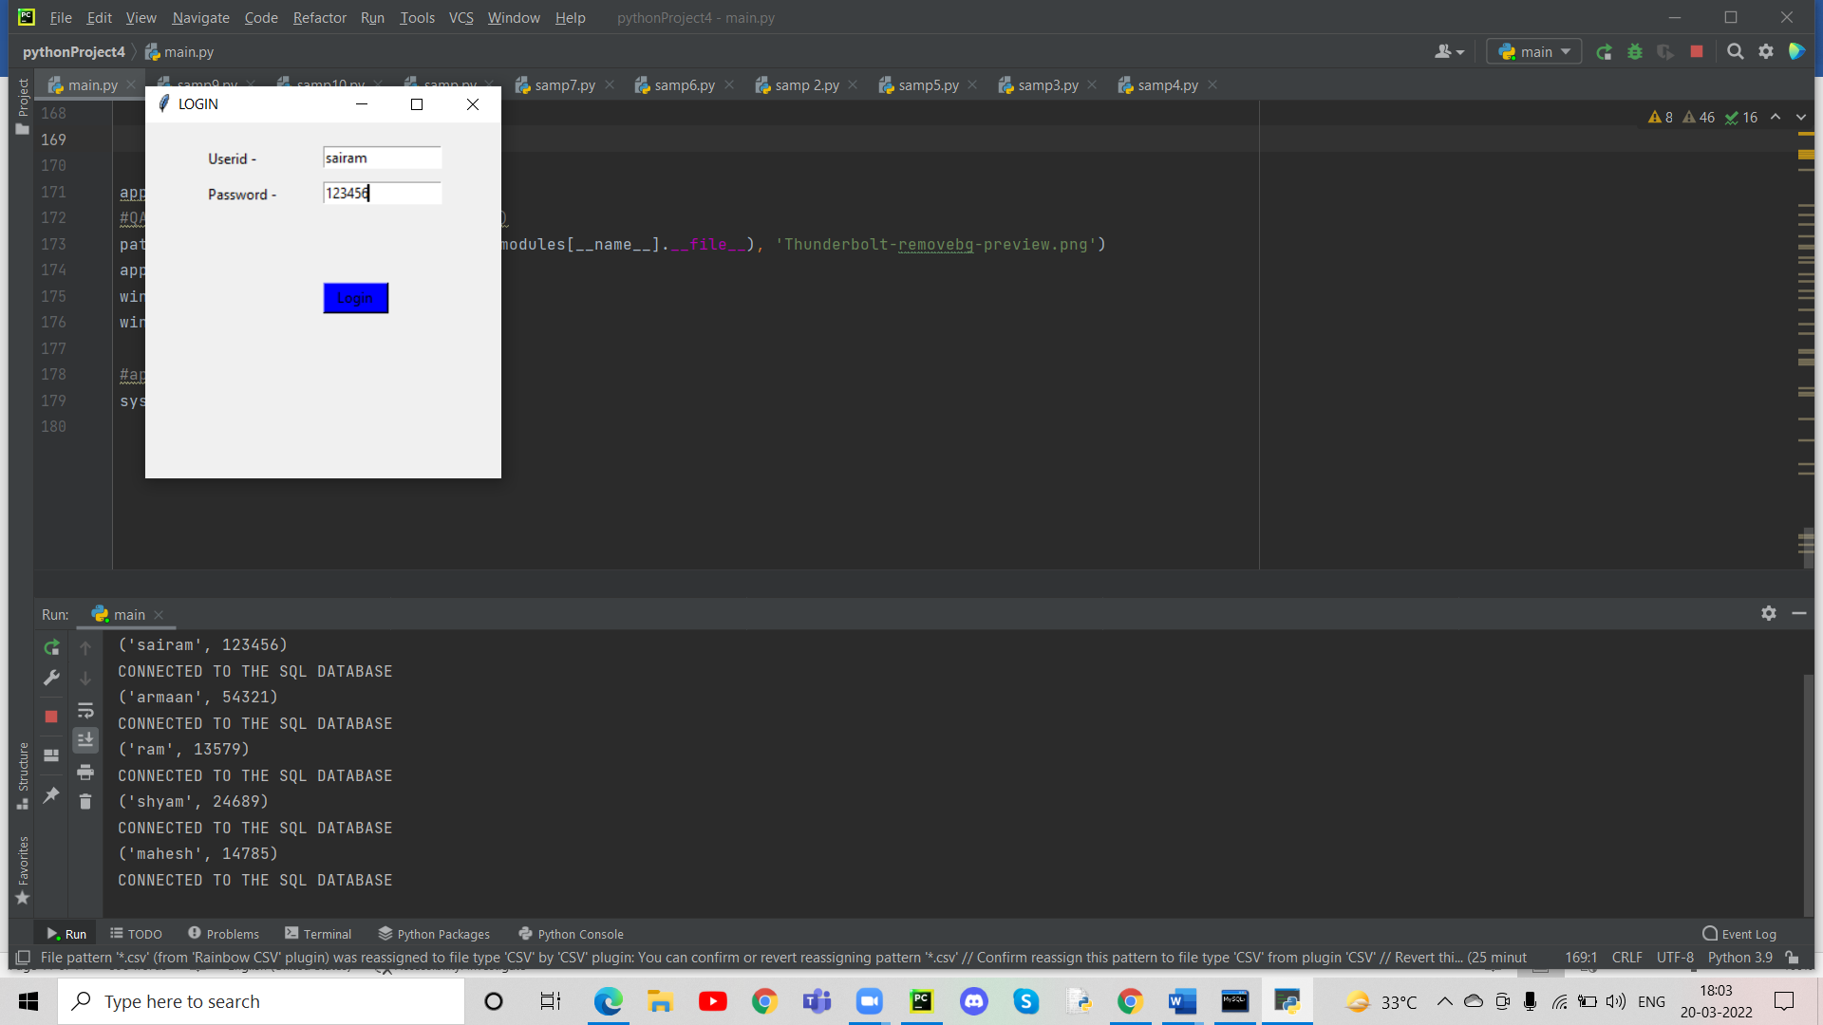



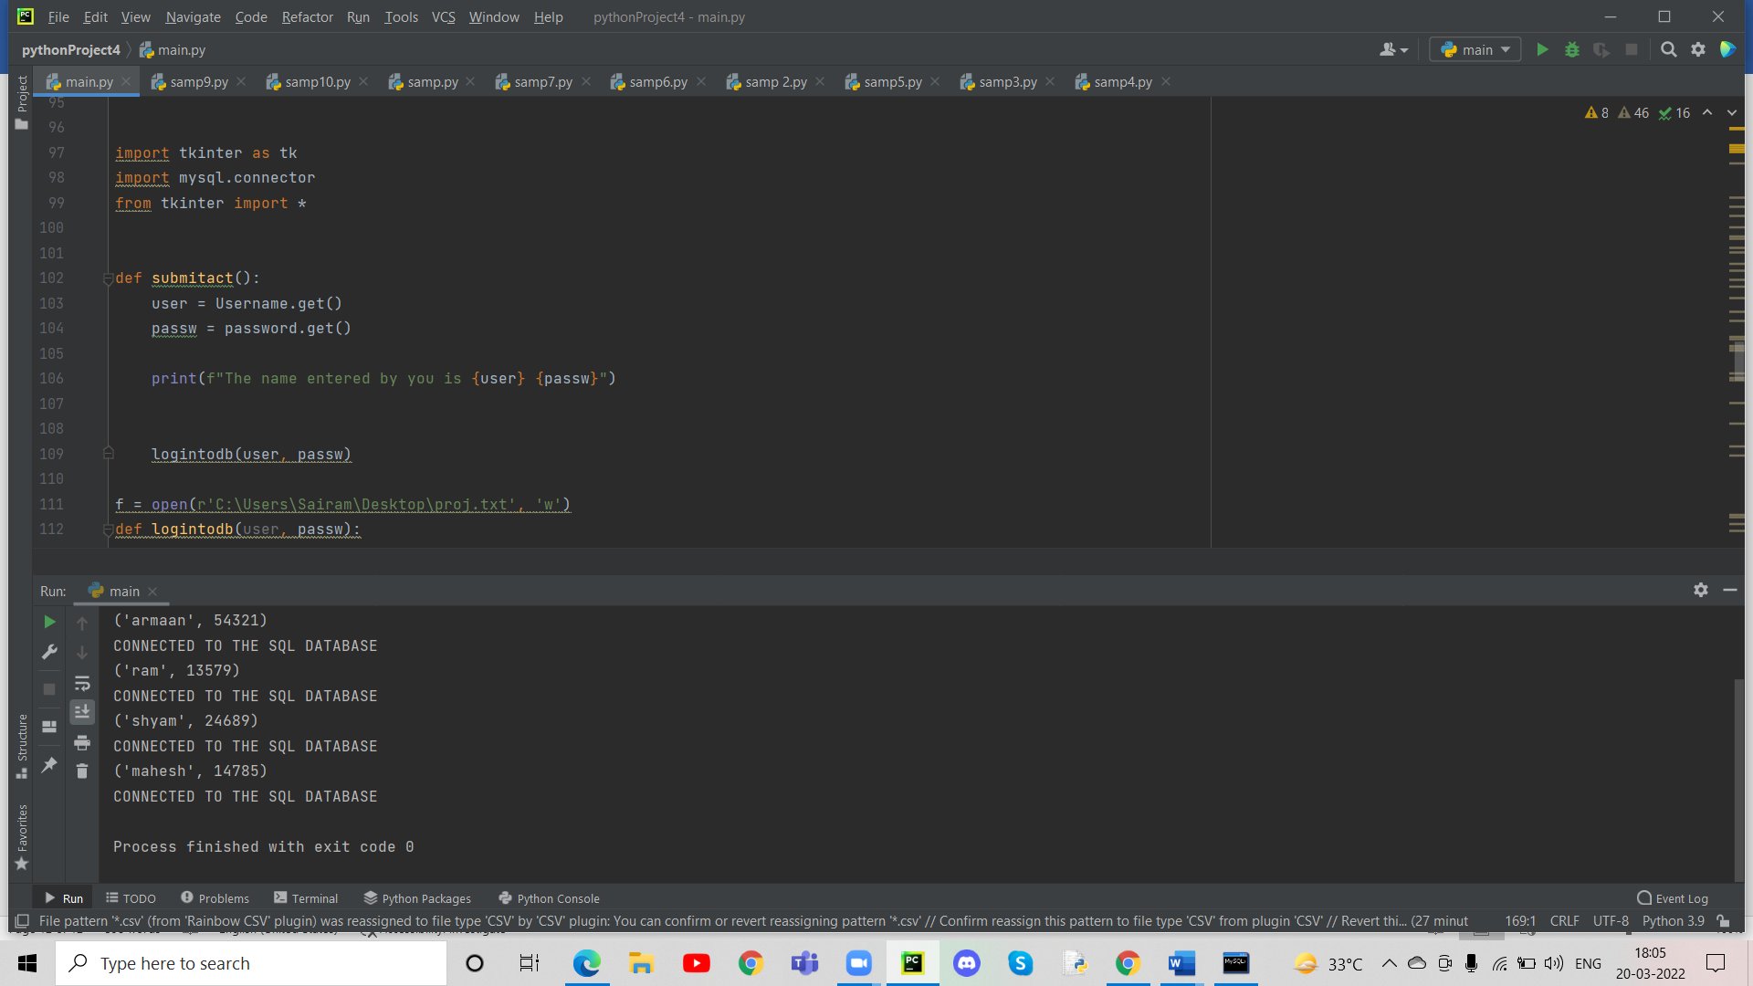

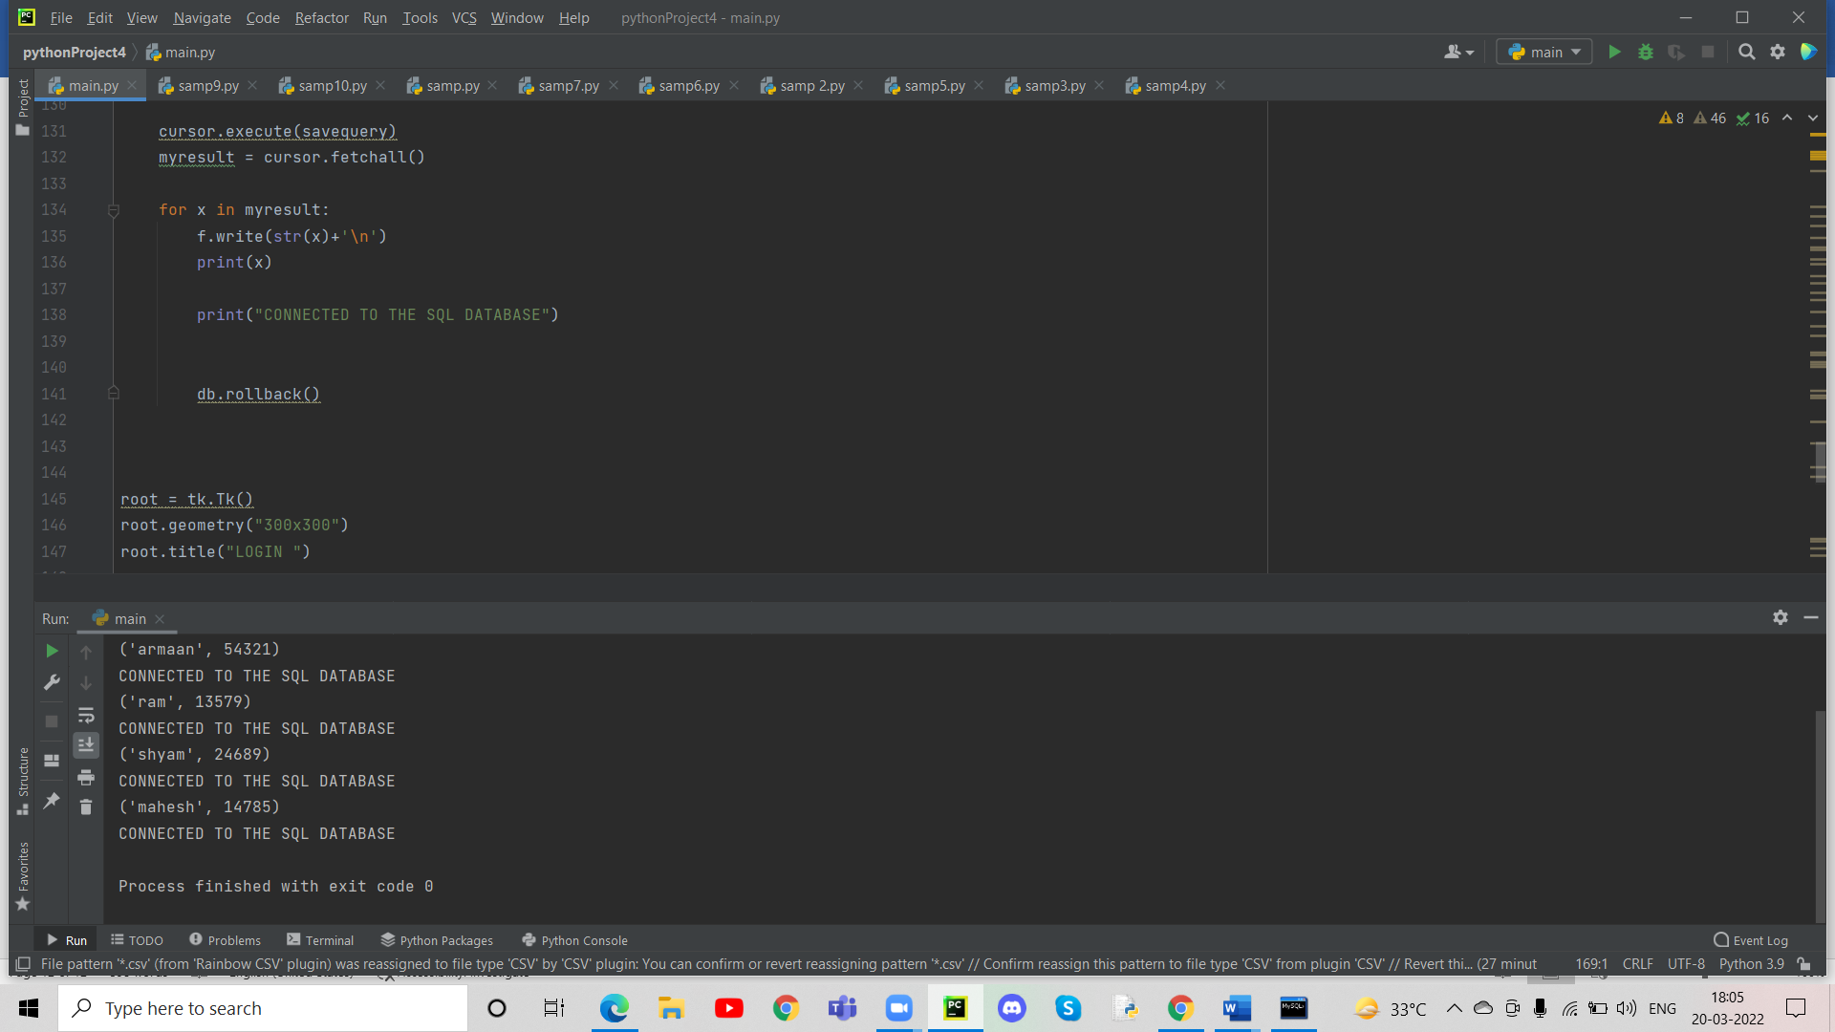

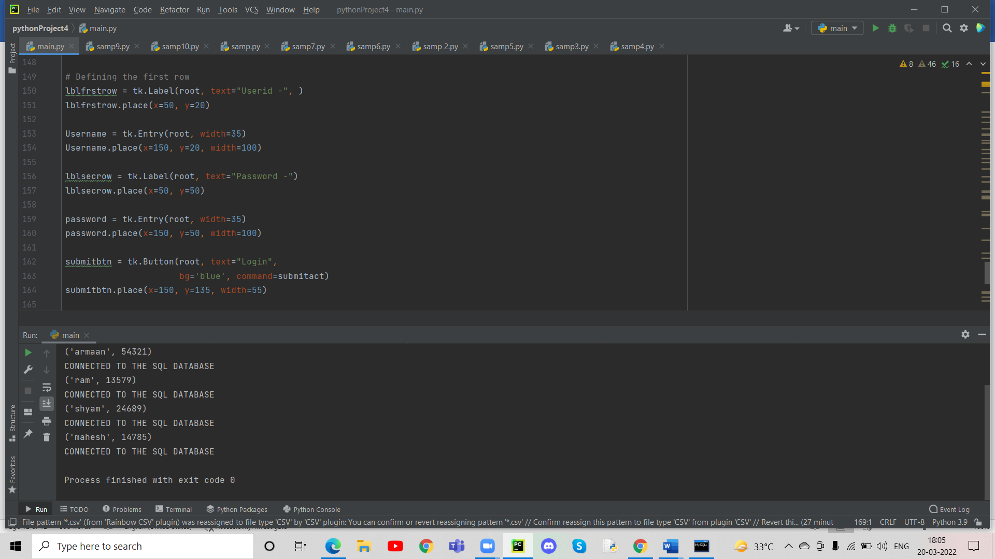

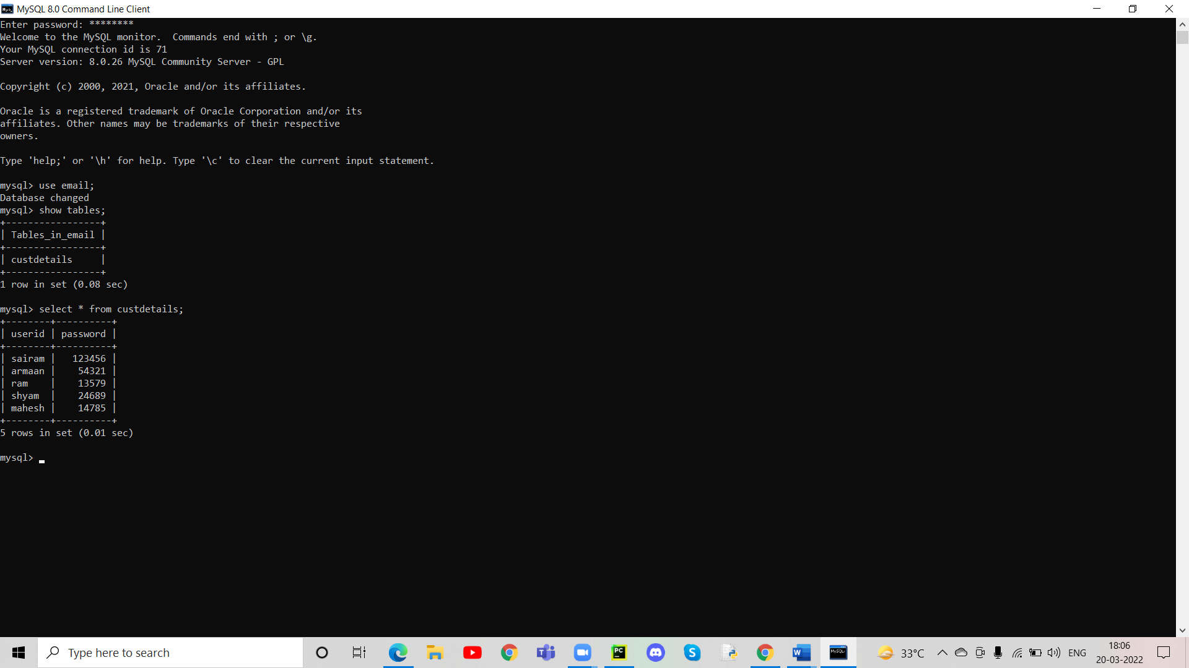

**TEXT FILE SCREENSHOTS:**

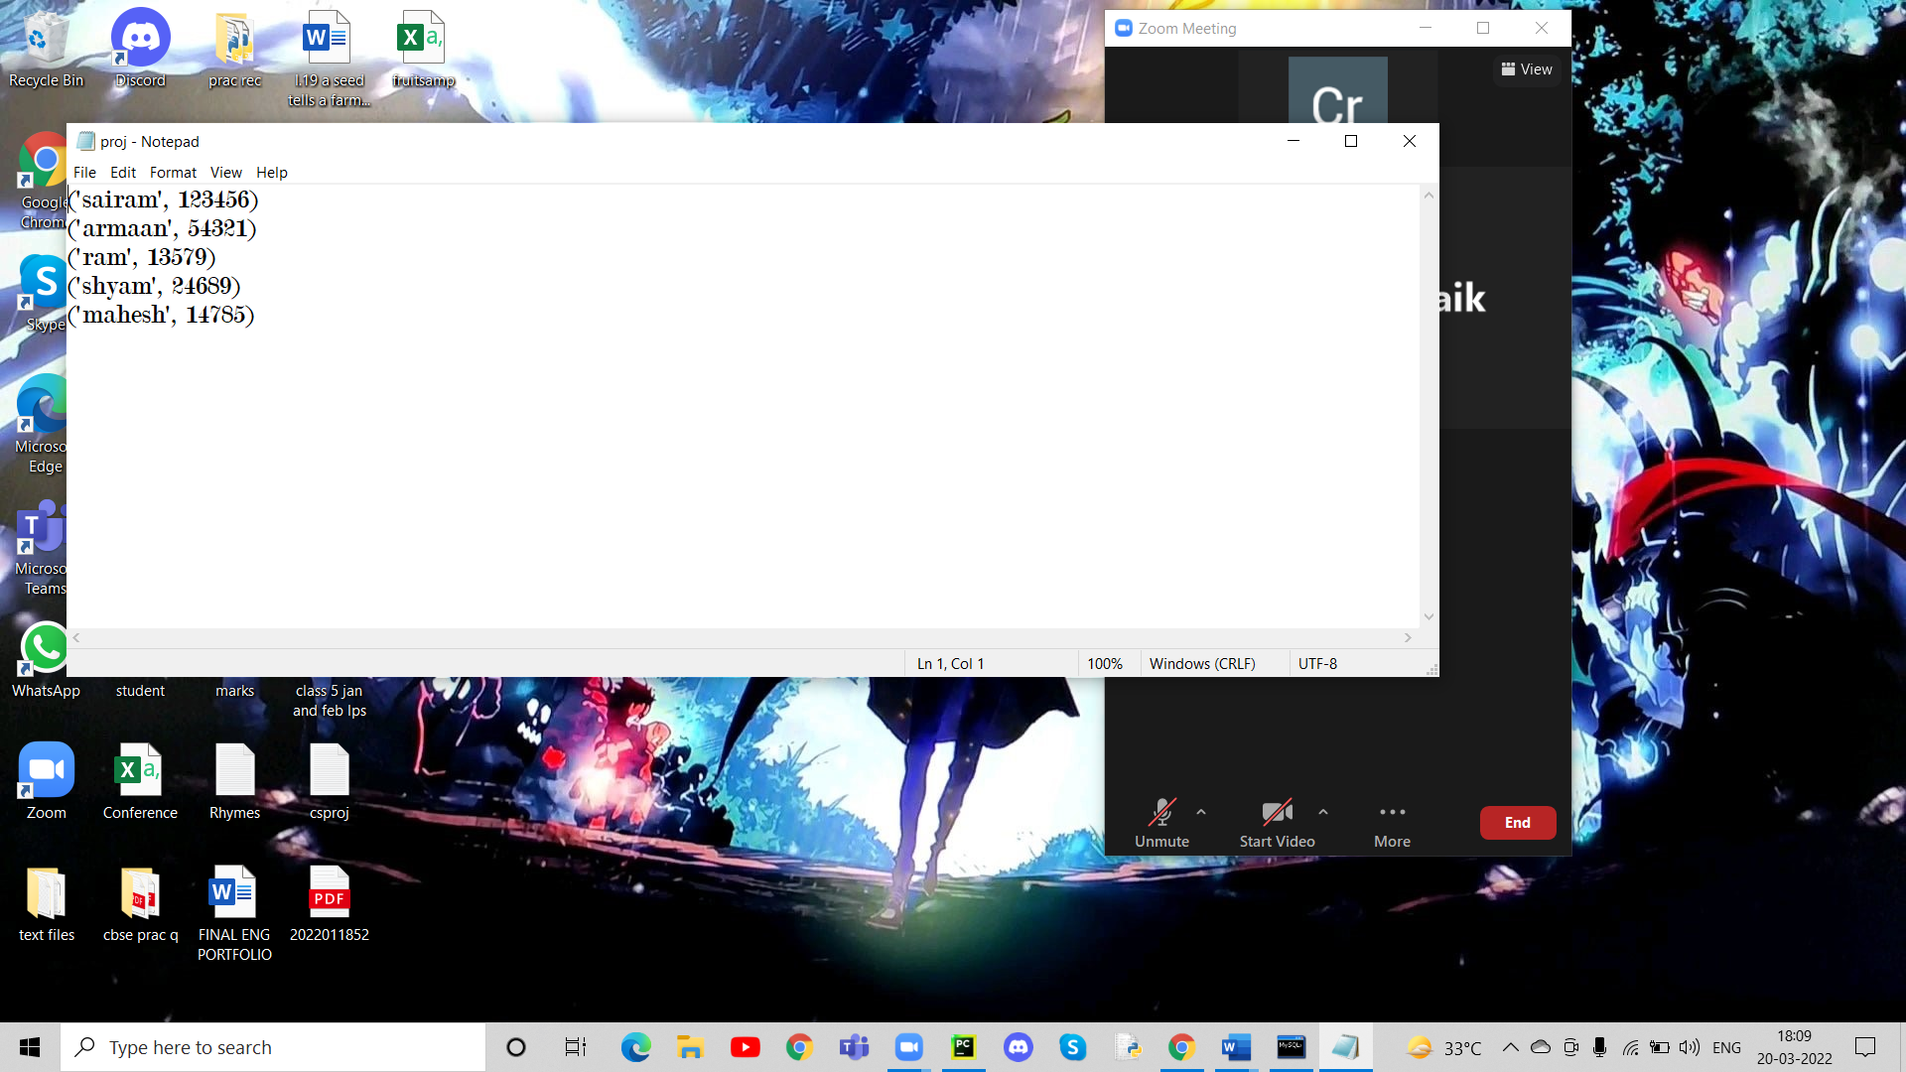

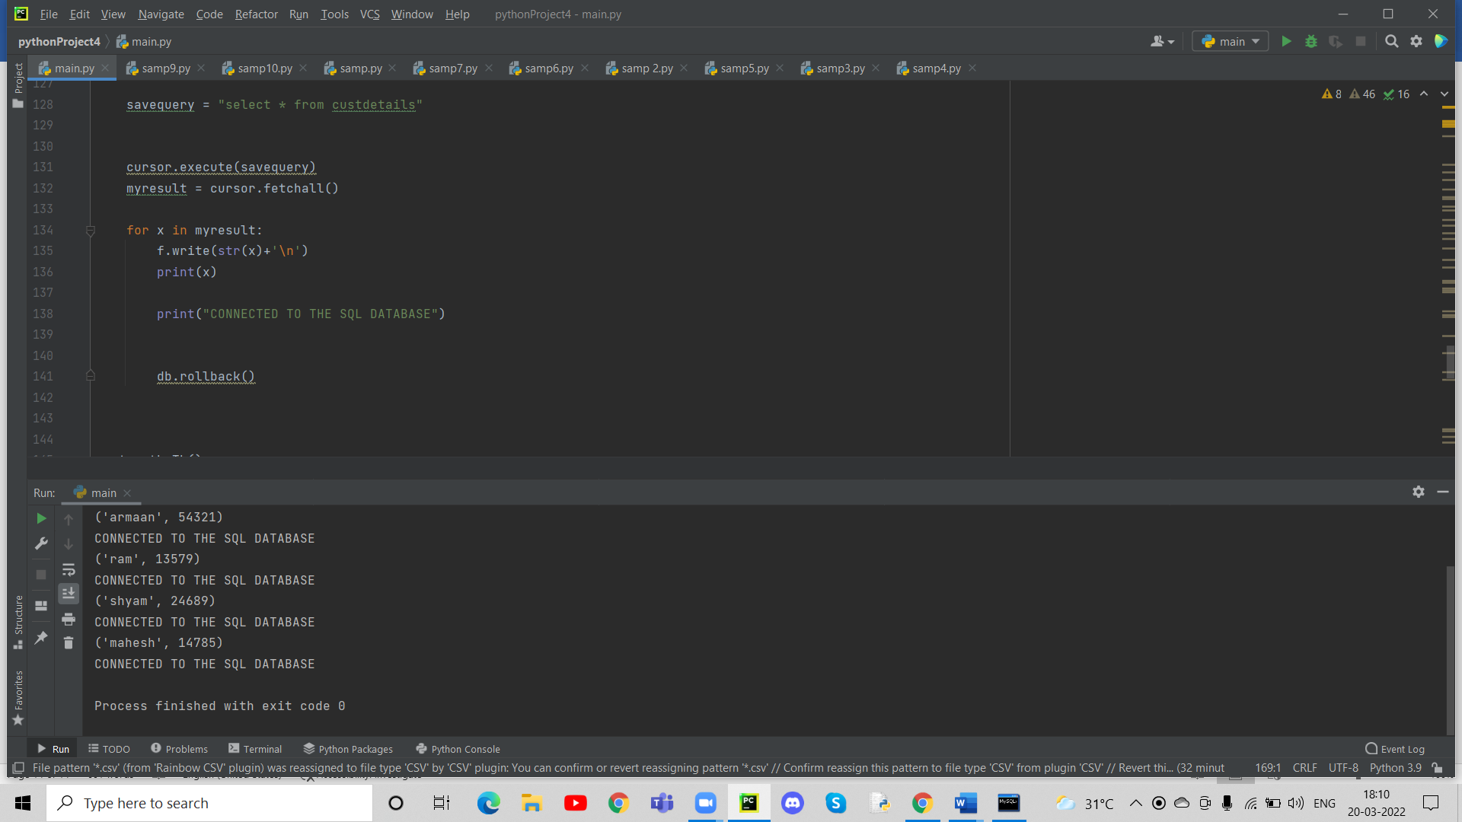

**FUTURE IMPROVEMENTS**

* When History is clicked in the browser.While there are certain links that appear but they don’t connect to any website when clicked on which would happen on a traditional browser. Therefore a text file can be used for storing the links that were visited and displayed here which would connect to the previous visited sites.
* When user button on the right of the status bar is clicked,It doesn’t show any user profile or the status of the user. This is another improvement that can be done to the browser so that it displays the user details or shows if any user is signed in at all like a traditional browser would do in this scenario.
* Even though there is a bookmarks option available on the toolbar it doesn’t really store any bookmarks.Once again a text file can be used here for storing the bookmarks which can be read from the text file and displayed here in the bookmarks option of the toolbar.

**BIBILOGRAPHY:**

1. **Tech with tim**

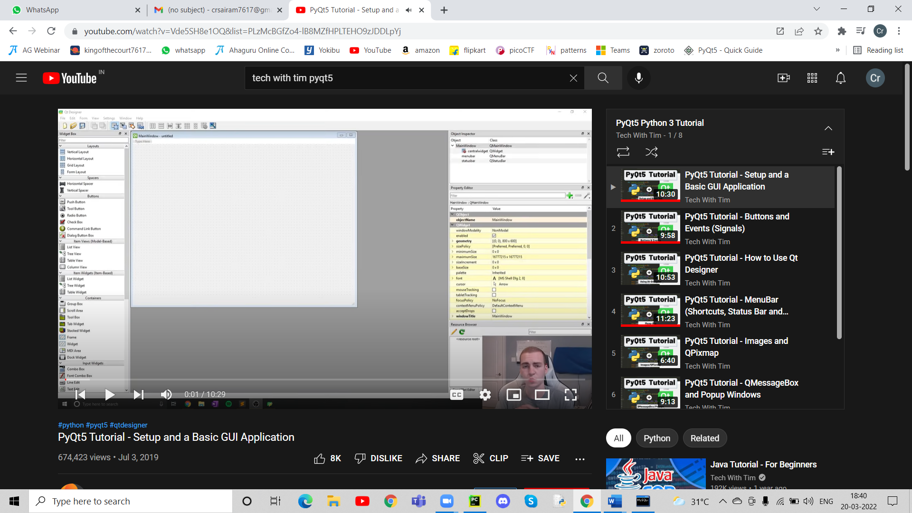

1. **Programming hero**

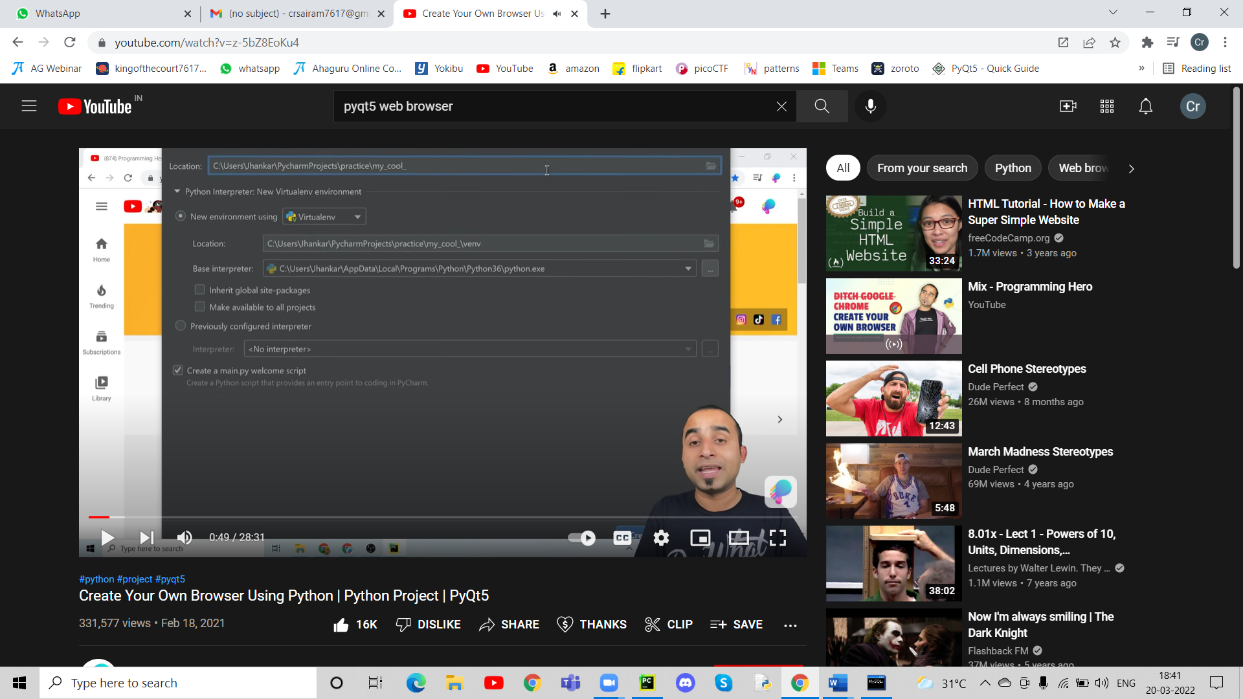

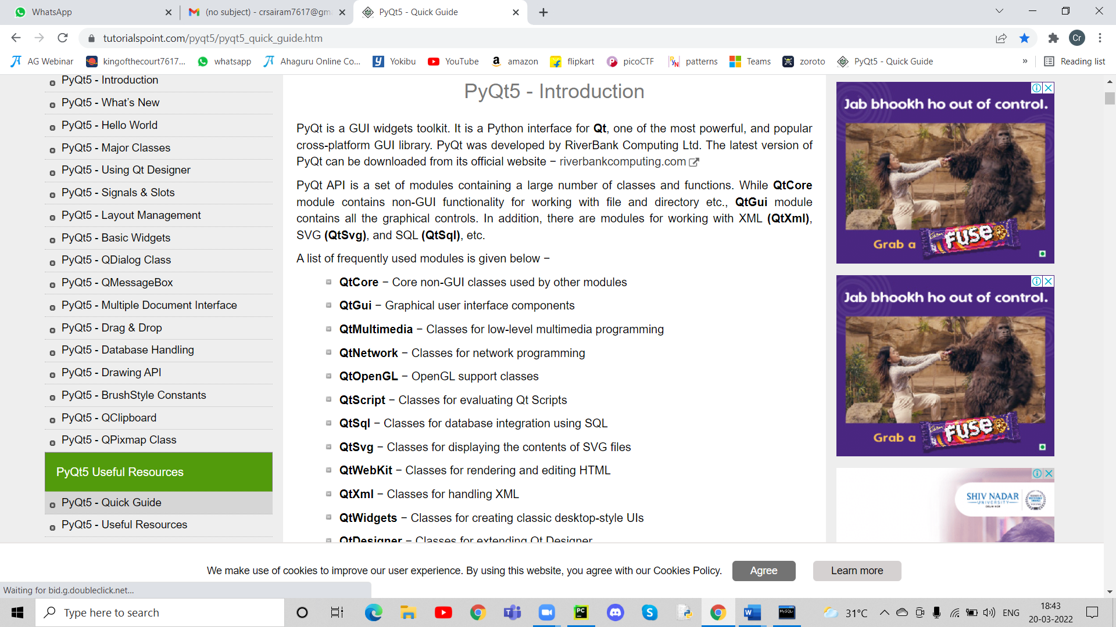

1. **Pyqt5 tutorials**
2. **Geeks for geeks**

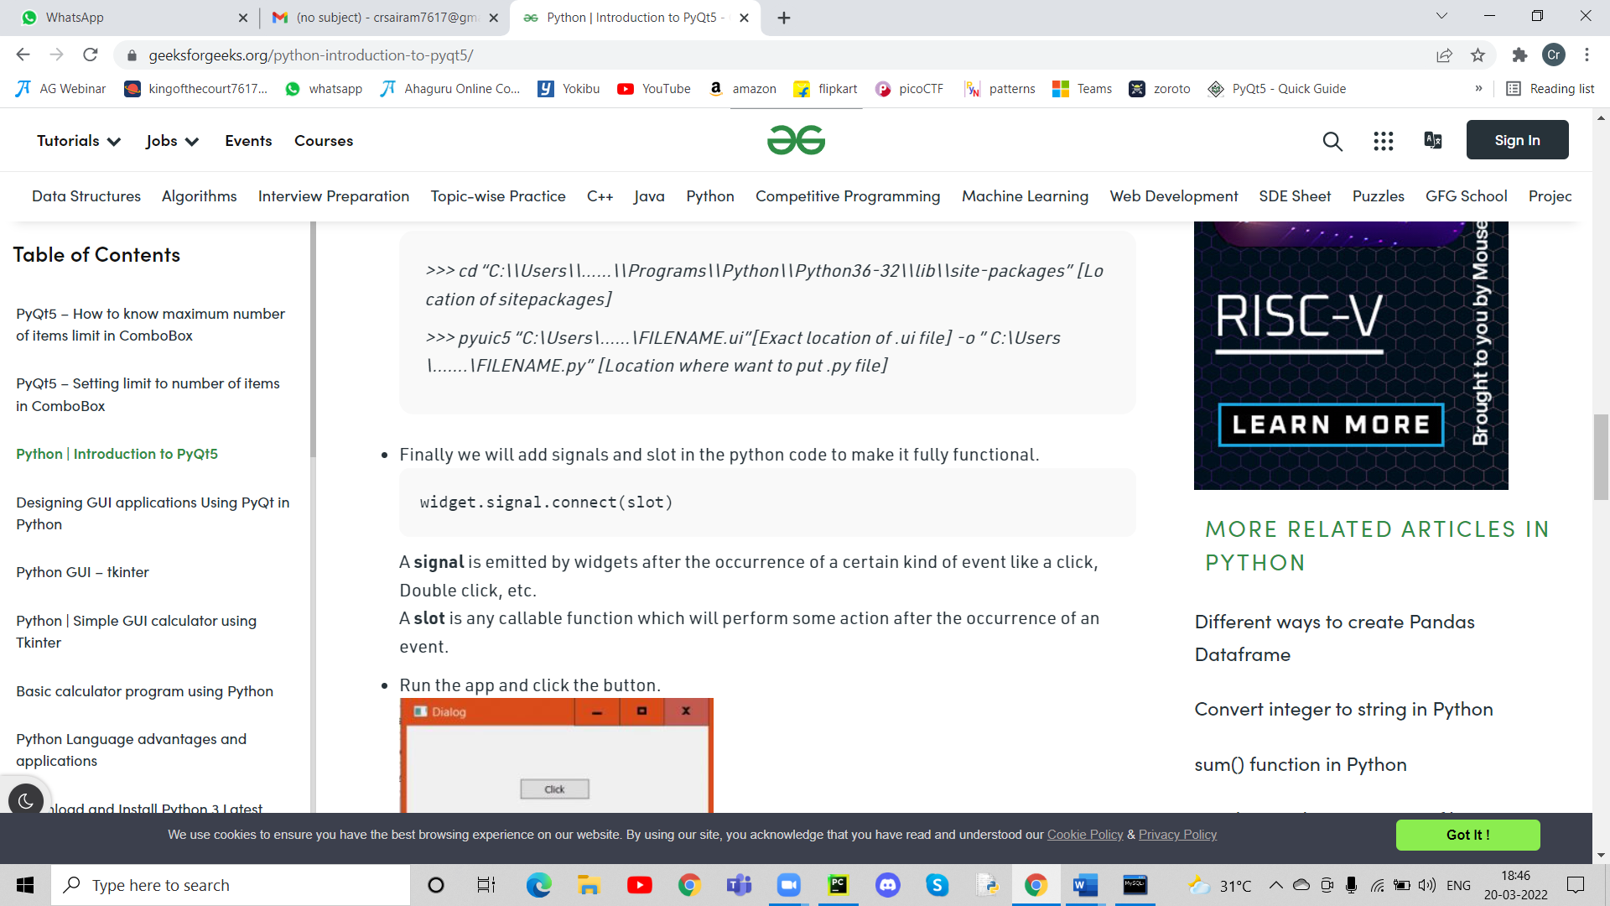

1. **Stackoverflow.com**

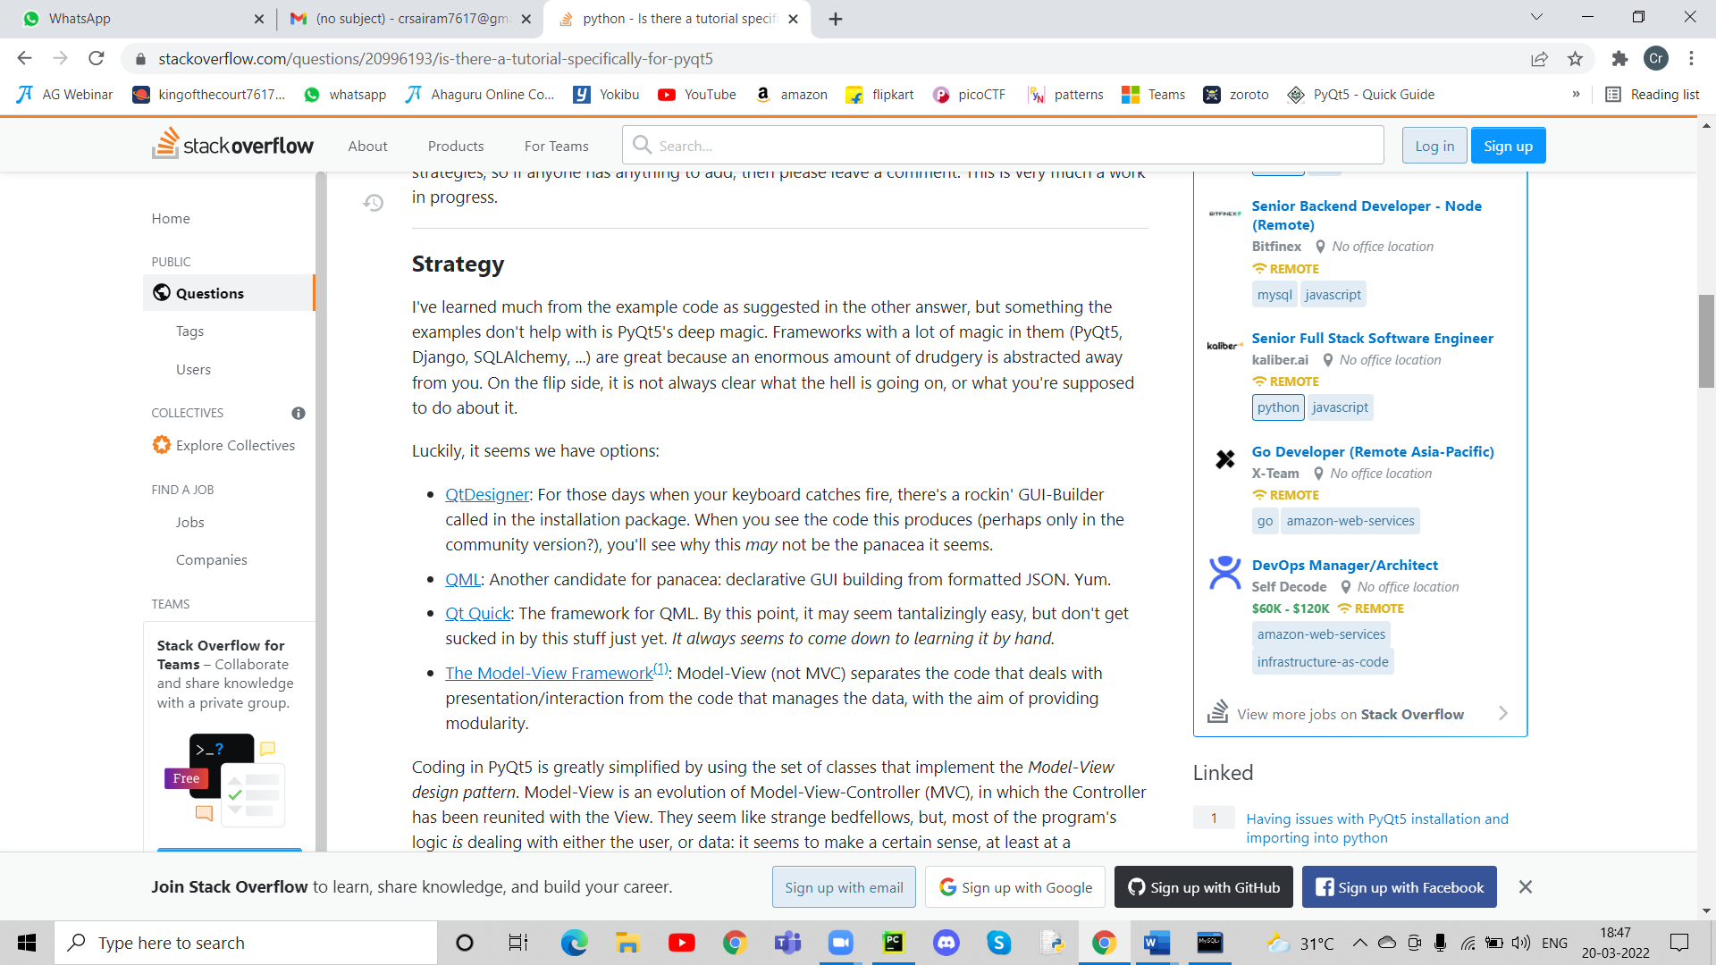

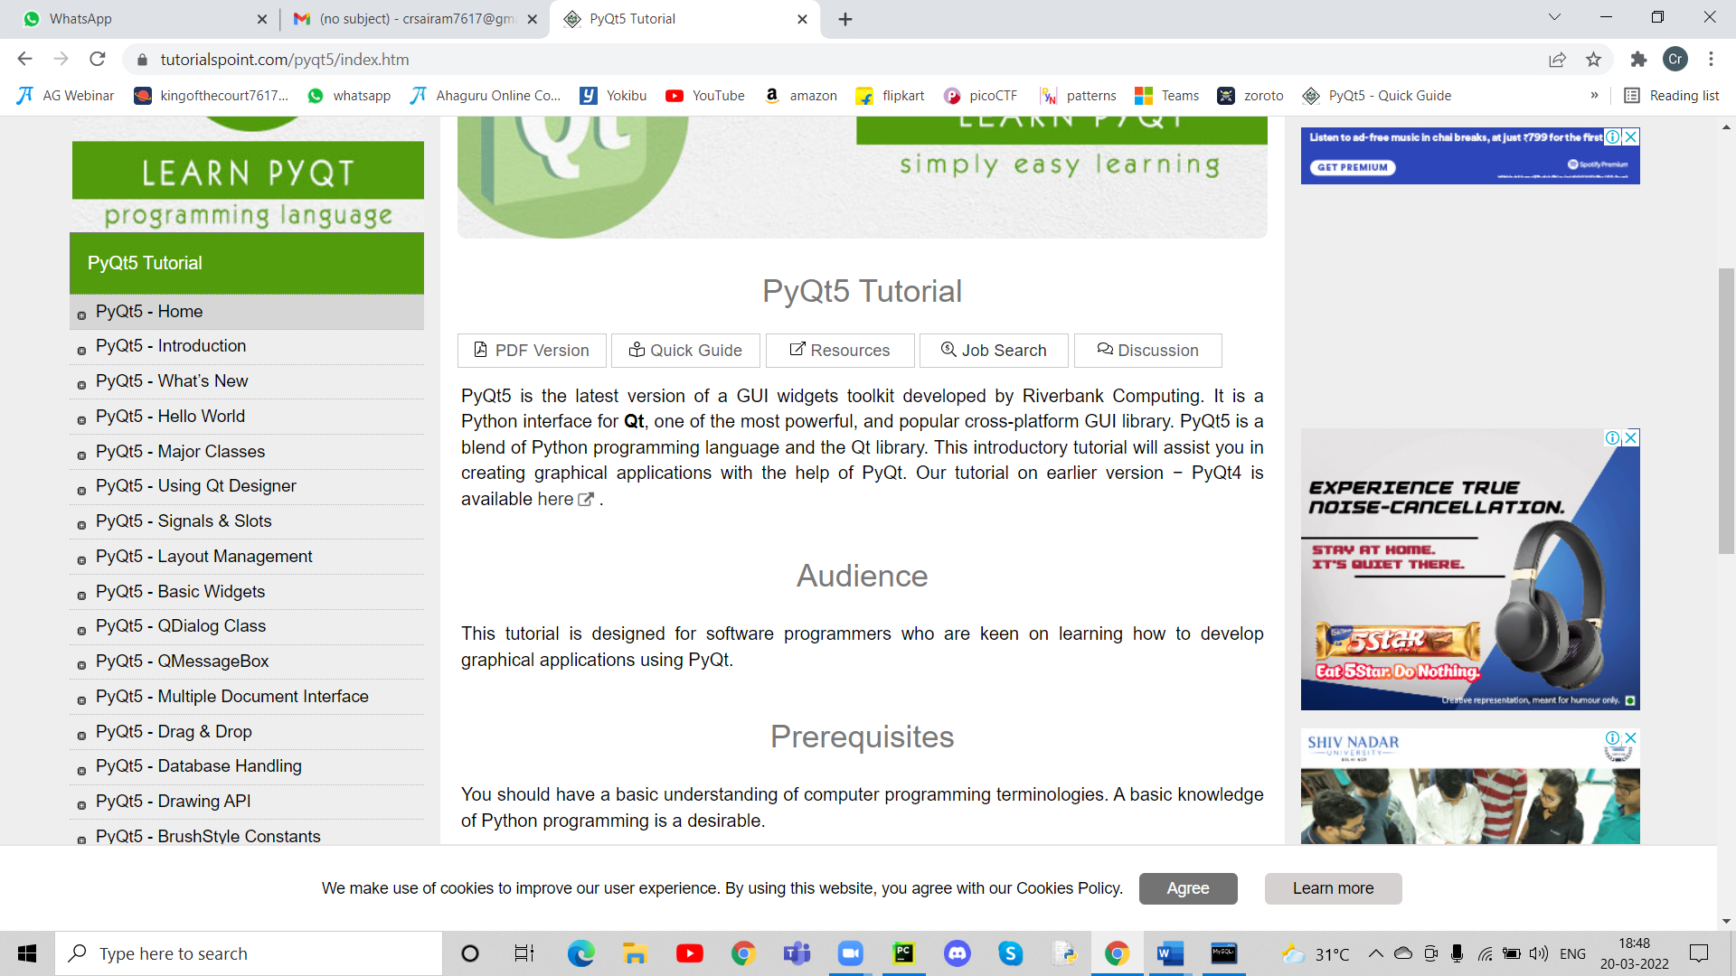

1. **Tutorialspoint.com**

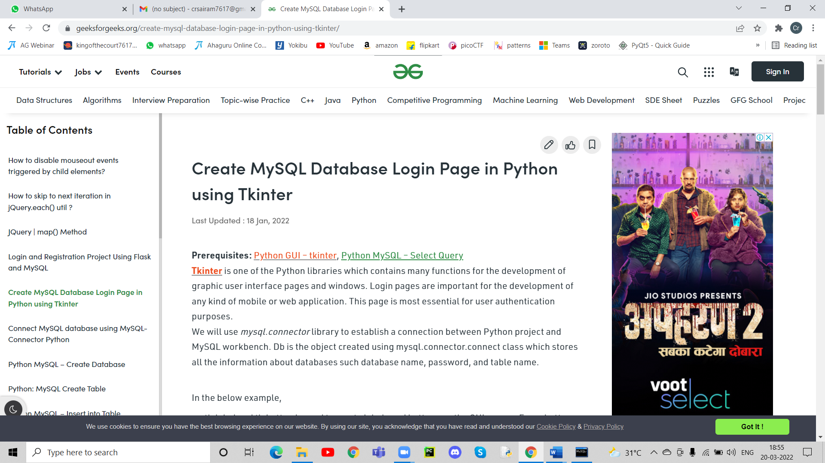

**7.SUMITA ARORA CLASS 12 COMPUTER SCIENCE**